TDPAdventurerGJ2G5

Game Design Document <version #0.1>

<Grupo 5 GameJam 2 cohorte 5>

<website>

Written by LAURA CRISTINA CORREA PATIÑO

<20-03-2024>

<Copyright info, ex. All Work Copyright ©2024>

<Studio Logo or Game Related Image>

# Index

Index

Overview

Elevator Pitch

Design Pillars

<Pillar #1>

<Pillar #2>

<Pillar #3>

Summary

Brief Description

Detailed Description

Theme/Setting/Genre

Main Objective

Aesthetics/Dynamics/Mechanics

Influences

What Sets This Game Apart?

Target Audience

Target Rating

Gameplay

Gameplay Summary

Brief

Detailed

Modes

Victory Conditions

Core Game Loop

<Element #1>

<Element #2>

<Element #3>

Core Gameplay Mechanics

<Mechanic #1>

Details

Implementation

<Mechanic #2>

Details

Implementation

<Mechanic #3>

Details

Implementation

Story

Brief Summary

Detailed Outline

Characters

Character #1

Character #2

Character #3

Level Design

<Level #1>

<Level #2>

<Level #3>

Conveyance Mechanisms

<Mechanism #1>

Cinematics

<Cinematic #1>

<Cinematic #2>

<Cinematic #3>

Technical

Screens

Title Screen

Game

Inventory

Combat

Options Menu

Credits

Game Engine

Controls

<Button #1> - <Default Binding>

Function #1

Function #2

Function #3

<Button #2> - <Default Binding>

Function #1

Function #2

Function #3

<Button #3> - <Default Binding>

Function #1

Function #2

Function #3

Development

Classes

<Base Class #1>

<Base Class #2>

<Base Class #3>

Visual Art

Style

UI/HUD

Assets Needed

Characters

Terrain/Environment

Objects

Promotional Material

Audio

Style

Music

Sound Effects

Voice Acting

Project Scope

Time Scale

Anticipated Gameplay Time

Cost

Target Platforms

Team

<Team Member #1>

<Team Member #2>

<Team Member #3>

Monetization

Schedule

<Task #1> - <due date>

<sub-feature #1> - <due date if needed>

<sub-feature #2> - <due date if needed>

<sub-feature #3> - <due date if needed>

<Task #2> - <due date>

<sub-feature #1> - <due date if needed>

<sub-feature #2> - <due date if needed>

<sub-feature #3> - <due date if needed>

<Task #3> - <due date>

<sub-feature #1> - <due date if needed>

<sub-feature #2> - <due date if needed>

<sub-feature #3> - <due date if needed>

Version History

V1.0 - <Major Changes>

V1.1 - <Major Changes>

V1.2 - <Major Changes>

## 

# Overview

## Elevator Pitch

2D Top-Down casual/puzzle game, with fun and medieval theme, made with enhanced classical assets and different challenge levels.

## Design Pillars

This is a puzzle casual game, with interaction between different type of doors and platforms that allow you to choose between one or more paths for the character to explore in levels. And to find the correct way to activate the path to follow.

### Environment

Tile palette designed, with different items and enhanced terrain to wander and interact. Also, some of this item acts as portals.

### Puzzles

This are the essence of this fun game because you as player need to find the right combination to solve it and go to the next exploration area.

### Player Movement

Our player can move freely around the environment, with the keys and arrows to find the items and interact with them, choosing which one is needed to complete the puzzle and break through the next level.

### Enemies

They try to hurt the player, but he can defend and use their remains to complete the puzzle.

## Summary

### Brief Description

This game is set on a Top-Down view, so everyone can se and walk across the ground and interact with the items, enemies and puzzles there, with increasing level of difficulties and some opponents to defeat.

### Detailed Description

In this game our player interprets a warrior trying to find his way home, after a wild night in the tavern, but his path is not easy because some creatures have come to feast from the forest resources, so the villagers have closed the gates and only the ones who find the right answers to the puzzles are going to get home safe and sound.

## Theme: Classic medieval

## Setting: 2D graphics Top-Down terrain, in limited zone but on different levels.

## Genre: Puzzle/Casual

## Main Objective

Our character main objective is to solve the puzzles and open the different path so he can arrive home safe after last night razzle.

## Aesthetics

Every time someone tries to find his/ her way home after a long party night is an adventure, so our player can identify them self with our warrior and make this experience a new interesting and fun road to remember this, and try to make them more enjoyable. Also, in some of this occasion is not easy to find our keys or some of our belongings, those things usually can be missing or lost, because we can´t remember where we have left them, or if we have leave them with friends or foes.

## Influences

### Influence #1 UnderMine

An action-adventure roguelike with a bit of RPG tossed in. Adventure deep into the UnderMine and discover powerful relics, deadly enemies, hidden secrets, and a few friends to help along the way. https://club.steam250.com/app/656350

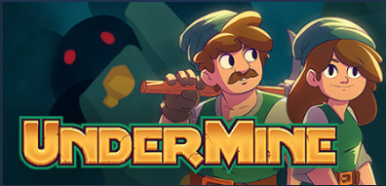

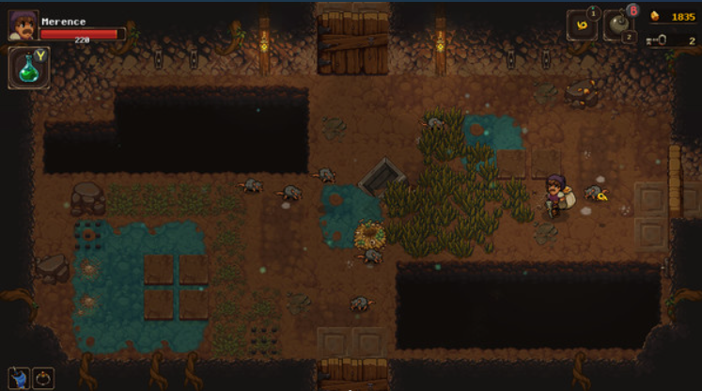

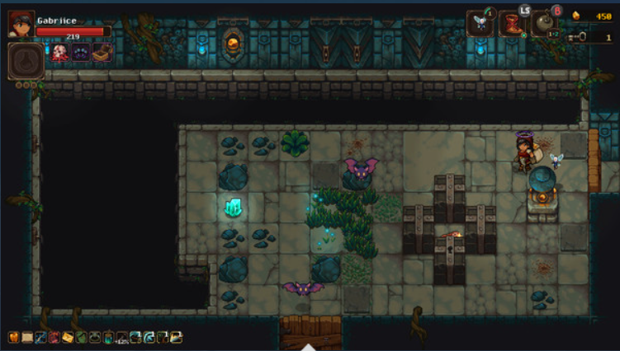

### Influence #2 Tomorrow won´t come for those without…

"Tomorrow won't come for those without ██████" is a surreal puzzle / visual novel short story by etherane, creator of Hello Charlotte. https://club.steam250.com/app/1334700

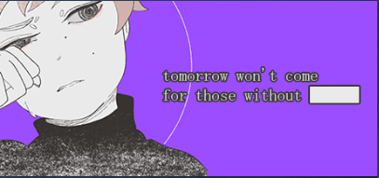

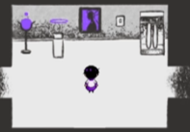

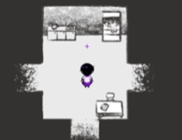

### Influence #3 Forests secret

s a cozy, nonviolent adventure game. You play as a traveler who has just arrived at a quiet forest settlement called Wabika, and must explore its mysterious paths, discover its ancient history, and make friends with its quirky inhabitants in order to find what it is you're searching for.

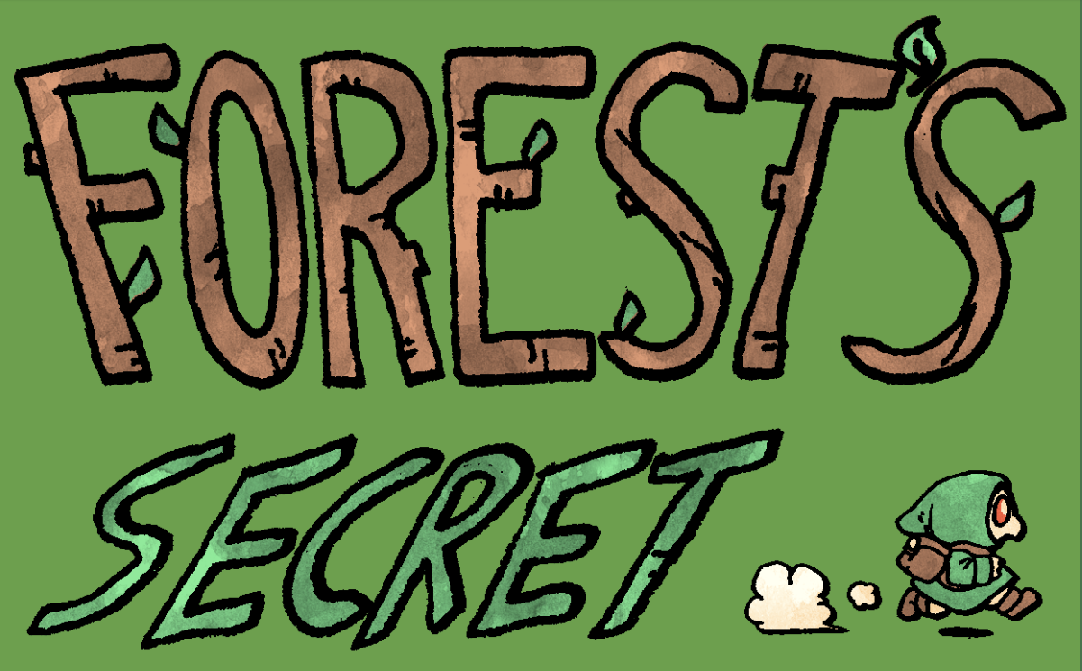

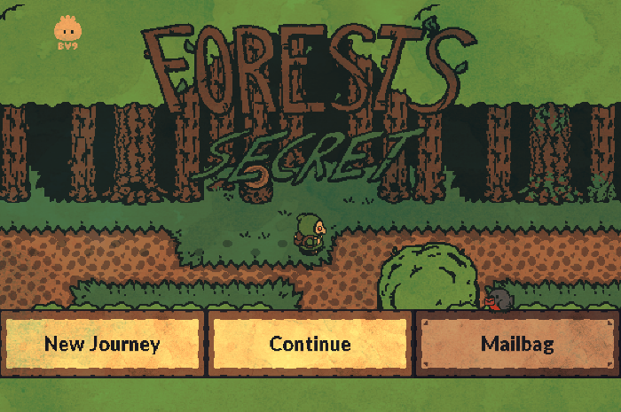

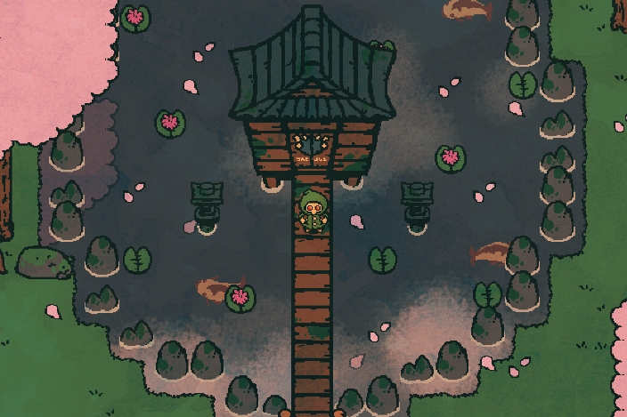

## Key Features

* Graphics and UI fully integrated and stylized
* Easy and fluid controls and interactions
* Fun and challenging levels
* Nice characters and elements

## Target Audience

This is mostly designed for adult audience and veterans in the industry who likes to enjoy some buzzing after a long working day.

## Target Rating

Rated E it may contain short reference to alcoholic beverages, not implicit.

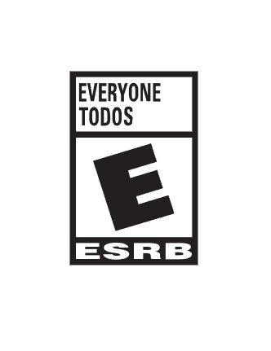

# Gameplay

## Gameplay Summary

Move the player around the terrain and try to find how to solve all the puzzles and open the doors, so you can walk your path, search in different levels and items so you can find those answers and arrive home safe.

### 

## Modes

Each level has some diverse kind of items, difficult and doors that can be opened.

Level 1 is the easiest with only 1 door and not a lot of things

Level 2 and 3 are medium arduousness, varies on doors and keys

Level 4 and 5 are high and you need to think a little more.

## Victory Conditions

The player needs to complete all puzzles, find the right paths and arrive home.

## Core Game Loop

### Element #1 Walk paths, all paths are similar, but they going to have some obstacles and little decorations to identify them

### Element #2 Solve puzzles, all of them are similar, but its requirements are very different to each kind

### Element #3 Interaction with enemies and items, to find the right ones.

## Core Gameplay Mechanics

### Mechanic #1 Explore

#### Details

* + Move between the terrain and levels, walk in every direction, dodge obstacles and set your rhythm.

#### Implementation

* + Basic character movement, colliders, gravity and animations.

### Mechanic #2 Solve

#### Details

* + Watch carefully on all details, find some similarities or resemblance of the objects and items in the scenery so you can relate them to find clues on how to solve each puzzle.

#### Implementation

* + Some items have distinctive color patrons, defined for each door as clue to find the one who interacts and let de player pass through.

### Mechanic #3 interacts

#### Details

* + Try to place the items in the corresponding place, attracting them and setting the place where they must stand so that the doors react

#### Implementation

* + Each interaction item can be moved to a new place and start some reaction if it is placed in the right stand.

# Story

## Brief Summary

On a Sunday morning after a good time with friend on the tavern our warrior finds himself in a part of the forest which he doesn´t remember been, so a little more self-aware, he tries to get home as soon as possible, but soon finds out, this task is not going to be nearly easy, and some matters urges him to close the distance home.

## Detailed Outline

<Be thorough! Use bullet points or mind mapping software if need be.>

# Characters

## Character #1

<Description>

<Include bullet points of features or concept art if possible.>

## Character #2

<Description>

<Include bullet points of features or concept art if possible.>

## Character #3

<Description>

<Include bullet points of features or concept art if possible.>

# Level Design

<If applicable, list out the various levels, biomes, worlds, etc. in your game and detail their attributes both in aesthetic and gameplay terms. Include a written description or flowchart outlining how the player will access the various levels.>

## <Level #1>

* Goal: <description>
* Mood/Theme: <description>
* <Objects/Enemies/NPCs/etc.>

## <Level #2>

* <Goal>
* <Mood/Theme>
* <Objects/Enemies/NPCs/etc.>

## <Level #3>

* <Goal>
* <Mood/Theme>
* <Objects/Enemies/NPCs/etc.>

# Conveyance Mechanisms

<List out the various ways information will be conveyed to the player. Ex. A health bar divided into six segments, each segment representing how much health is lost from one hit. Ex. How will the player know certain objects are interactable?>

<Ideally this should include figures.>

## <Mechanism #1>

## <Mechanism #1>

## <Mechanism #1>

# Cinematics

<List out any cinematics in the game. Making beat sheets may be helpful.>

## <Cinematic #1>

## <Cinematic #2>

## <Cinematic #3>

# Technical

## Screens

### Title Screen

<Description>

### In-Game

<Description>

#### Inventory

* <Description>

#### Combat

* <Description>

### Options Menu

<Description>

### Credits

<Description>

## Game Engine

<Note what game engine you will use and explain why.>

## Controls

<Note the buttons the game needs to have, their in-game functions, and their default bindings. (ex. Action Button (A) - pick up / put down objects, talk to NPCs, initiate combat, etc.)>

<Figures may be necessary to illustrate how controls work especially for mobile or VR games.>

<Also include things like whether or not the player can change key bindings. Does the game support controllers and/or keyboards?>

### <Button #1> - <Default Binding>

#### Function #1

#### Function #2

#### Function #3

### <Button #2> - <Default Binding>

#### Function #1

#### Function #2

#### Function #3

### <Button #3> - <Default Binding>

#### Function #1

#### Function #2

#### Function #3

# Development

## Classes

<List out the classes you’ll use in bullet point format beginning with base classes and ending with derived classes. (ex. Player, Npc, and Monster might all derive from the Creature class. Going further, Goblin and Bear might both derive from Monster.) For the player and enemies, include core properties such as health, speed, damage, attack rate, and jump height (if applicable) to help paint a picture about their behaviors. >

### <Base Class #1>

* + <Scripts>

#### <Derived Class #1>

* + - <Scripts>

#### <Derived Class #2>

* + - <Scripts>

#### <Derived Class #3>

* + - <Scripts>

### <Base Class #2>

* + <Scripts>

#### <Derived Class #1>

* + - <Scripts>

#### <Derived Class #2>

* + - <Scripts>

#### <Derived Class #3>

* + - <Scripts>

### <Base Class #3>

* + <Scripts>

#### <Derived Class #1>

* + - <Scripts>

#### <Derived Class #2>

* + - <Scripts>

#### <Derived Class #3>

* + - <Scripts>

# Visual Art

## Style

<Define your art style here. Is your game 2D or 3D. Consider color palettes, graphic style, mood you’re trying to convey, camera type (1st/3rd person, top down), lighting, etc. Is your game realistic, cartooney, low poly, abstract? What are the influences? If using pixel art, define things like thick black outlines or smooth curves over sharp angles. Consider visual feedback to convey information to players. (ex. Making a box sparkle to show you can open it.)>

<Use visuals to convey this: sketches and concept art of locations, characters, etc. - Great for getting a sense for what the game will look like and for presenting the idea to stakeholders.>

## UI/HUD

<Describe elements such as the user interface, heads up display, and quest selection menu if applicable. Note functionality, options, animations, etc. List out all widgets and their functionality. Ideally this should include concept art, flowcharts, and/or wireframes.>

## Assets Needed

<For each type of asset, specify: file formats, naming conventions, programs to use, size of asset, etc.>

### Characters

* <Character #1> (<animations>)
* <Character #2> (<animations>)
* <Character #3> (<animations>)

### Terrain/Environment

* <Terrain #1>
* <Terrain #2>
* <Terrain #3>

### Objects

* <Object #1> (<animations>)
* <Object #2> (<animations>)
* <Object #3> (<animations>)

### Promotional Material

* <Promo Piece #1>
* <Promo Piece #2>
* <Promo Piece #3>

# Audio

## Style

<Define the overall mood/tone your audio will help deliver to the player. Silly, grim, realistic, etc. How will you deliver this? Genre, instruments, tempo, key, mood, etc. Include example references.>

<Consider what you want to emphasize to the player through the sound effects.>

## Music

<List songs you’ll need at various parts of your game or descriptions of the type of song you’ll need if you haven’t picked a specific song for that part of your game yet. Include where a song will be played and what mood/tone it is helping to set.>

* <Song #1>
* <Song #2>
* <Song #3>

## Sound Effects

<List sound effects, how/where they will trigger, and any other details.>

* <Sound Effect #1>
* <Sound Effect #2>
* <Sound Effect #3>

## Voice Acting

<Consider which, if any, characters will have spoken dialogue. What type of voice and emotions will be needed for each character?>

# Project Scope

## Time Scale

<How long will the game take to make? Will there be beta releases or DLC? Use the schedule as a guide.>

## Anticipated Gameplay Time

<How long do you expect players to take completing the game?>

## Cost

<How much will the game cost to make?>

<Include a breakdown of all costs such as paying team members, licenses, hardware, etc.>

## Target Platforms

<List platforms you plan on releasing the game for and the minimum specs required to play the game.>

## Team

#### <Team Member #1>

* <Role>
* <List things like cost to employ this team member here.>

#### <Team Member #2>

* <Role>
* <List things like cost to employ this team member here.>

#### <Team Member #3>

* <Role>
* <List things like cost to employ this team member here.>

## Monetization

<Monetization Type - Paid Alpha/Beta/Final, Ad Driven, Micro-transactions, Subscription, etc.>

# Schedule

<This is essentially your ordered checklist for when to make what feature or complete a task such as technical goals, DLC plans, raising funds, release date, marketing goals, etc.>

<Break the large tasks down into small easy-to-tackle problems. Include realistic dates to keep yourself on track. Remember to first work on what you need for your minimum viable product.>

## <Task #1> - <due date>

### <sub-feature #1> - <due date if needed>

### <sub-feature #2> - <due date if needed>

### <sub-feature #3> - <due date if needed>

## <Task #2> - <due date>

### <sub-feature #1> - <due date if needed>

### <sub-feature #2> - <due date if needed>

### <sub-feature #3> - <due date if needed>

## <Task #3> - <due date>

### <sub-feature #1> - <due date if needed>

### <sub-feature #2> - <due date if needed>

### <sub-feature #3> - <due date if needed>

# Version History

A record of major changes made to this document.

## V1.0 - <Major Changes>

* <Details>

## V1.1 - <Major Changes>

* <Details>

## V1.2 - <Major Changes>

* <Details>